Pratical no:1

Code:

print("--------student Details-------")
Name=input ("Enter your name:")
Age=input("Enter your Age:")
City=input("Enter your City:")
PRN=input("Enter your PRN:")

print("-------Show student Details-------")
print(f"Name:”,Name)
print("Age:",Age)
print("City:",City)
print("PRN:",PRN)
Output:

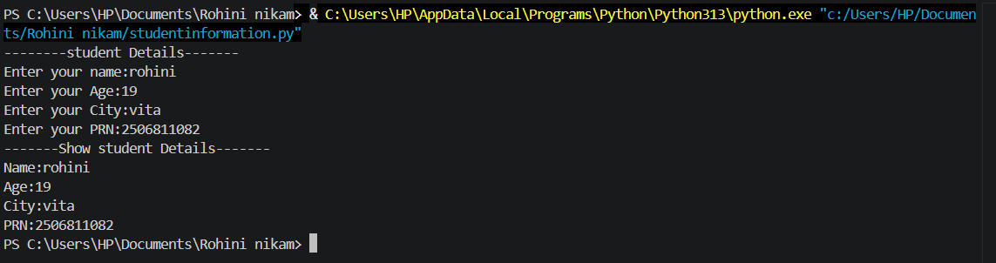

Exercise

Q.01: Develop a program that accept a student’s marks for three different subjects, calculates their total and average, and prints a final scorecard with the average rounded to two decimal places.

Code:
mark1=float(input("Enter mark of subject 1:"))
mark2=float(input("Enter mark of subject 2:"))
mark3=float(input("Enter mark of subject 3:"))

total=mark1+mark2+mark3
average=total/3

print("-------------final scorecard---------")

print("subject 1=",mark1)
print("subject 2=",mark2)
print("subject 3=",mark3)
print("total=",total)
print("average",average)

Output:

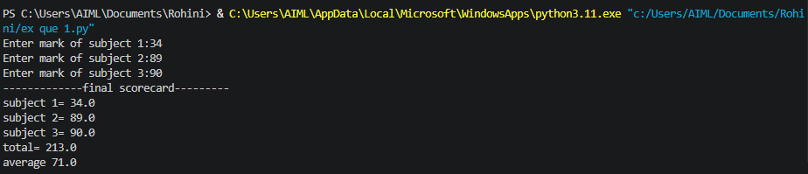

Q.02:Create a simple profile generator that takes an employee's name, role, and monthly salary, and prints out a formatted text-based employee identity card.

Code:

print("-------------Employee profile generator---------")
name=input("Enter employee name:")
role=input("Enter employee role:")
salary=float(input("Enter employee montly salary:"))

print("------------employee identity card----------")
print("name=",name)
print("role=",role)
print("salary=",salary)

Output:

